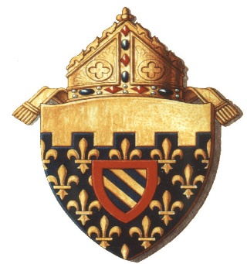

August 7, 2020

Dear Families and Friends of Saint Albert Catholic School and the Greater Council Bluffs Communities,

Each day in the COVID-19 era brings rapidly evolving circumstances and considerations that impact our lives. We are called to be discerning as we make important decisions on behalf of our families. The education and overall spiritual formation of our young people is at a pivotal juncture, and we enlist all our resources--academic, financial, innovative and technological—so that our children realize their human dignity and unique talents and skills.

The most precious resource we share is our Catholic Christian faith, along with the love and service to neighbor our faith inspires. Our hope and prayer is to enable our students to lead meaningful lives that unite and enrich persons from diverse backgrounds. We do all we can so they can take up their God-given part in the local and global community.

Saint Albert Catholic School has been fulfilling this mission for generations. Saint Albert has been exemplary in demonstrating the agility to move swiftly from on-site to remote learning pedagogies. The leadership team is assembled and is ambitiously looking to further the visionary strategic plan that is being thoroughly implemented. As we stand on the verge of a new academic year, teachers and staff are poised to deliver in-school, hybrid, and distance learning styles as needed, and to gracefully adapt and change on a moment’s notice.

The Saint Albert Catholic School community recently received news of another sort of change. Deacon Vernon Dobelmann brought energy and enthusiasm to the newly created executive director position at Saint Albert last year. As he steps down from this role, we want to thank him for his dedication and perseverance. Under his leadership, the unique cradle-to-college school stabilized enrollment and staff retention, strengthened and deepened the faith formation program and began a capital campaign. We are grateful for all that he has accomplished in his short time with the Diocese of Des Moines and wish him well as he moves to be closer to his extended family, and to wherever the Spirit leads. And we will ambitiously undertake a search for his successor, knowing that with our present executive team in place we are already in sure and capable hands for this new academic year.

Jesus commends the house that is built on solid rock, that can withstand the stormy winds and unfriendly forces that would otherwise stir fear and leave us exposed to factors beyond our control (see Matthew 7:24-27). Saint Albert Catholic School is firmly set on the rock of faith, supported by the many families and friends who are generously dedicated to ensuring that every child will be welcomed with open arms. We guarantee that every young person is equipped with the education and experiences he or she is meant by God to receive, and which every parent or guardian seeks.

On behalf of the Diocese of Des Moines, we pledge our firm commitment to be strategic partners and advocates for Saint Albert Catholic School. And we offer our prayers and trust that God will not be outdone in graciously fulfilling his promises to us.

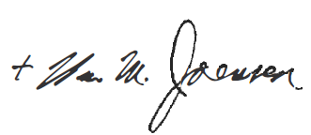
Faithfully in Christ,
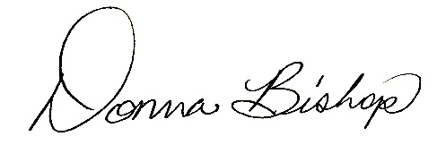
Most Rev. William M. Joensen, Ph.D. Donna Bishop, Ed.S.
Bishop of Des Moines Superintendent of Catholic Schools

