Saint Albert Dance Team
Winter Mini Dance Clinic 2016

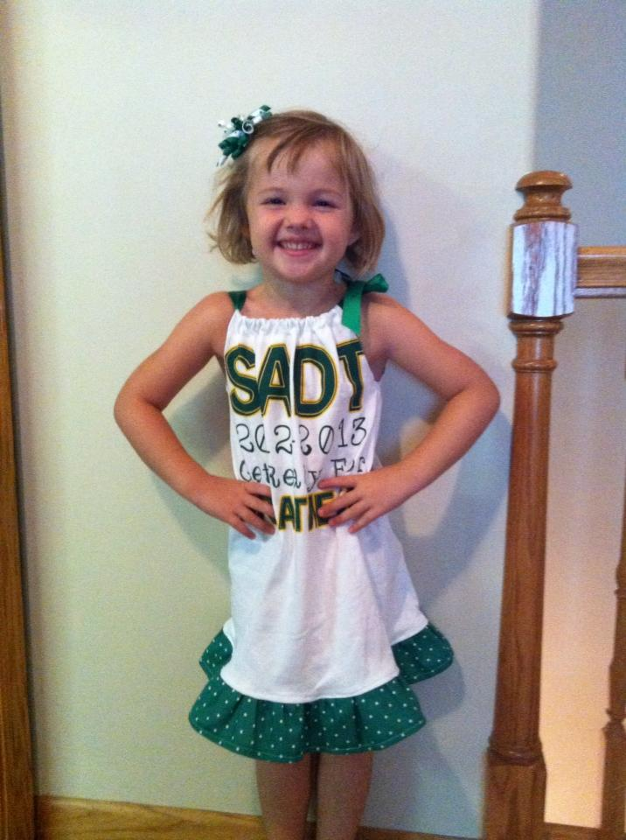
Sunday, February 21st
Registration from
1:30 – 2:00pm
Clinic 2:00 – 4:00pm
$25.00 per child
Pre-K - 6th grade
Held at Kerri’s Dance Studio
1851 Madison Ave Suite 500
Spirit items will be available for purchase. Snacks will be provided.
Pre-Registration is helpful but not required. Registrations accepted at the door.

Kids will learn a dance with the Varsity dance team, have a snack and showcase the dance for their parents. Participants are invited to perform at the S.A. Dance Team Season Showcase on Feb. 27th at 7:00pm in the high school gym. If you have any questions please contact coach Kerri Watts at kjo123@cox.net.
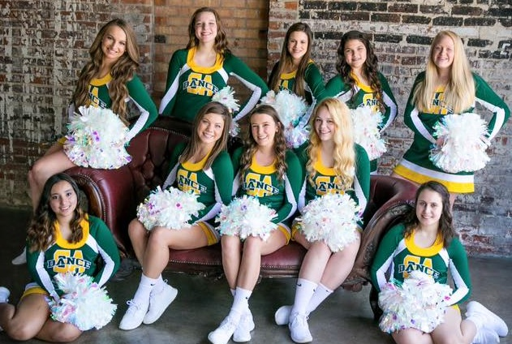
Pre-Registration form for SADT Winter Mini Dance Clinic

Students Name - __________________________________

Parent Name - ___________________________________

Contact info – Phone ___________________

Email - ____________________

Students grade - ______________

Snacks will be provided - Any known allergies (especially food) or other special needs we should know about ?

Payment - Check # _____________ Cash _____________

Thank you – Looking forward to a great day!!

