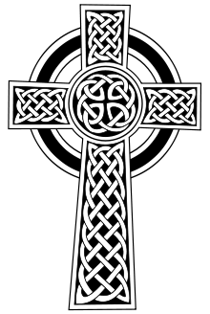
Feast of
St. Patrick Festival
SATURDAY, MARCH 14, 2015
MASS 4:00 PM
DINNER 5:00 – 8:00 PM
St. Albert High School, 400 Gleason Ave, Council Bluffs

Homemade Irish Dinner featuring Corned Beef & Cabbage, Ham, Potatoes, Green Beans & Carrots, Bread, Desserts, and Drinks
Hot Dog & Chips for Children

Cost: $10 for Adults, $5 for Children (ages 6-12), Free for children under 5

Kids Games, Baked Goods, Crafts, Silent Auction, & Raffle

POT OF GOLD RAFFLE
TICKETS: $20 each OR 3 for $50
1ST PRIZE $1000 CASH
2ND PRIZE $ 500 CASH
3RD PRIZE $ 300 CASH
4TH PRIZE $ 200 CASH
5TH PRIZE $ 100 CASH

DRAWING HELD MARCH 14, 2015 - NEED NOT BE PRESENT TO WIN
PURCHASE TICKETS AT THE DOOR OR CALL ST. PATRICK’S AT 323-1484

